## Option 1: Heroes of Pymoli

by Jessica Caccamo

due 2/21/19

3 Trends in Video Game Purchases this period and Recommendations for Sales Growth:

1. Female gamers as they spend more than men per game
   1. Recruit more female gamers via discounts for referring friends
2. The age groups that spends the most per game are <10 and 35-39 age groups.
   1. Prioritize user recommended games by most profitable games as this group is least price sensitive.
3. The age groups that have the most users and spend the most and buy most frequently are 15-24 years groups.
   1. Prioritize user recommended games by most popular games to maintain and increase engagement.

Total Number of Players = 576

### Purchasing Analysis (Total) – Some Players made more than one purchase



### Gender Demographics – An overwhelming majority of players are male.

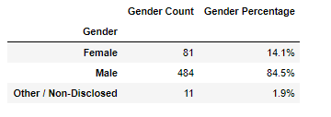

### Purchasing Analysis (Gender) – Even though female players make up a lower percent the demographic, they spend on average more than male player.

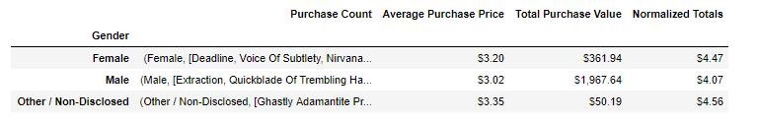

### Age Demographics: 68% of players are between the ages of 15-24 spending an average of $3.11, with a majority being 20-24 spending$3.02. These players spent the most, but the under 10 and 35-39 year olds spent the most per item with an average purchase price of $3.40 making them the least price sensitive groups but also the smallest.

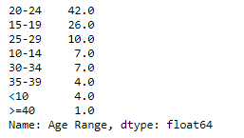

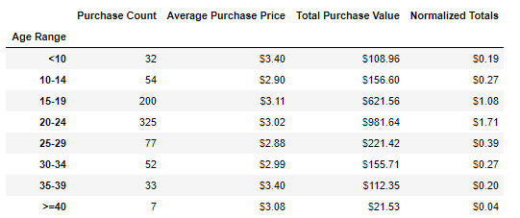

### Top Spenders – These 5 users spent the most in total purchases with the lowest purchases in the top 5 being 3 and the highest 5.

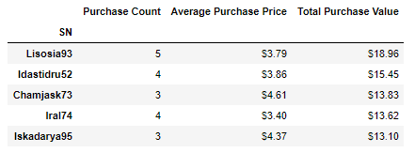

### Most Popular Items – The most popular items were purchased a minimum of 8 times.

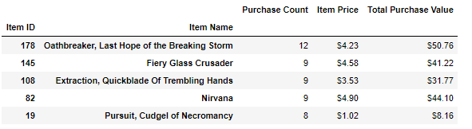

### Most Profitable Items – The most profitable items were purchased a minimum of 2 times but all had purchase values near $10.

